Can Vision-Language Models Assess Pedagogical Quality of AI-Generated Math Diagrams?

Vishal Kumar & Saad Ashraf
Stanford University

1. Introduction

The rapid proliferation of AI-generated educational content presents a fundamental quality assurance challenge. Large language models can now produce mathematical diagrams, instructional visuals, and other pedagogical materials at a scale that far outpaces human review capacity, yet each diagram must meet pedagogical standards before being deployed in front of learners. Expert quality assurance has become the bottleneck to responsible deployment.
This tension between scale and quality is particularly acute in mathematics education, where visual representations play a critical role in student understanding. A poorly designed diagram can actively mislead, introducing misconceptions that are difficult to correct (Mayer, 2001). As AI-generated instructional materials become embedded in educational technology platforms serving millions of students, the stakes of unreviewed content grow proportionally.

1.1 Cognitive Theory of Multimedia Learning

Mayer’s Cognitive Theory of Multimedia Learning (CTML) provides a well-established theoretical framework for evaluating the pedagogical design of visual instructional materials (Mayer, 2001). CTML rests on three assumptions about human cognition: that learners process visual and verbal information through separate channels (dual coding), that each channel has limited processing capacity, and that meaningful learning requires active cognitive processing—selecting relevant information, organizing it into coherent mental models, and integrating it with prior knowledge.
From these assumptions, Mayer and colleagues derived a set of empirically validated design principles, each supported by decades of controlled experiments. Among these, five principles are particularly applicable to the evaluation of standalone mathematical diagrams:
- Coherence: Visual displays should contain only relevant elements, excluding extraneous decoration that competes for limited cognitive resources (Mayer & Fiorella, 2014).
- Signaling: Visual cues such as arrows, color coding, and highlights should guide the learner’s attention to essential information and organizational structure.
- Spatial Contiguity: Related elements—such as labels and the objects they describe—should be placed in close spatial proximity to reduce the cognitive effort of visual search.
- Segmenting: Complex information should be broken into manageable, digestible chunks rather than presented as a monolithic display.
- Appropriate Labeling: Essential mathematical elements should be clearly labeled, but not over-labeled or under-labeled, so that the diagram supports rather than overwhelms comprehension.
These principles have proven effective at predicting learning outcomes across a wide range of multimedia instructional contexts. However, they have not been systematically applied to evaluate AI-generated mathematical diagrams, nor have they been tested as a framework for automated assessment by vision-language models.

1.2 Vision-Language Models and Mathematical Diagrams

Recent advances in vision-language models (VLMs)—multimodal LLMs that process both images and text—have prompted a wave of benchmarking efforts aimed at understanding their mathematical reasoning capabilities. MathVista (Lu et al., 2023) introduced a comprehensive benchmark of over 6,000 examples evaluating mathematical reasoning in visual contexts, revealing that even the strongest models (GPT-4V at 49.9% accuracy) fell substantially short of human performance. MathVerse (Zhang et al., 2024) extended this line of work with 2,612 math problems specifically targeting diagram understanding, demonstrating that many VLMs rely heavily on textual cues while struggling with genuine visual comprehension.
These benchmarks share a common orientation: they evaluate whether VLMs can answer mathematical questions about diagrams—that is, whether the model understands the mathematical content depicted. This is an important capability, but it is distinct from the question we pose. We are not asking whether a VLM can solve a math problem depicted in a diagram. We are asking whether a VLM can evaluate whether the diagram itself is well-designed for teaching—whether its visual organization supports or hinders a student’s ability to learn from it. This is an assessment of pedagogical design quality, and it requires a different kind of visual judgment.

1.3 The LLM-as-Judge Paradigm
The idea of using large language models as automated evaluators—the “LLM-as-judge” paradigm—has gained significant traction in the NLP community. Zheng et al. (2023) demonstrated that strong LLMs can achieve over 80% agreement with human evaluators when judging open-ended text quality, while also identifying systematic biases including position bias, verbosity bias, and self-enhancement bias. This work established both the promise and the limitations of automated evaluation: LLM judges can approximate human judgment at scale, but their reliability varies across tasks and must be empirically validated.

The extension of this paradigm to visual assessment—using VLMs as judges of image quality—is a natural next step, but one that introduces additional complexity. Visual pedagogical judgment requires the model to perceive spatial relationships, evaluate design choices, and reason about how a learner would process the visual information. These are capabilities that current VLMs possess to varying degrees.
Applying the LLM-as-judge framework to educational content evaluation is particularly promising for the EdTech sector, where the cost of expert human review creates a direct constraint on the pace of content deployment. If VLMs can reliably assess even a subset of pedagogical design dimensions, they could serve as a first-pass filter—flagging diagrams that clearly violate design principles for human review while allowing well-designed diagrams to proceed. The practical value of such a system depends entirely on the empirical question of how well VLM assessments align with expert human judgments.

1.4 The Present Study

To our knowledge, no prior work has investigated whether vision-language models can assess the pedagogical design quality of mathematical diagrams. Existing benchmarks evaluate mathematical comprehension; existing LLM-as-judge research focuses on text quality; and existing CTML research relies on human evaluation. Our study sits at the intersection of these three lines of work:
To what extent do VLM assessments of diagram quality align with human expert judgments across different pedagogical dimensions and mathematical domains?

We operationalize this question using a dataset of 2,421 unique AI-generated mathematical diagrams spanning nine K-12 domains, five binary assessment dimensions derived from CTML, human expert annotations collected from practicing K-12 mathematics teachers, and parallel automated assessments from four state-of-the-art VLMs (Claude Sonnet 4.6, GPT-5.2, Gemini 3.0 Pro, and one open-source model). Agreement is measured using Cohen’s kappa, computed per dimension, per model, and per mathematical domain.
This design allows us to move beyond a single aggregate measure of VLM reliability and instead map the landscape of automated pedagogical assessment: identifying which dimensions of design quality VLMs can reliably evaluate, which remain the province of human expertise, and whether certain types of mathematical diagrams pose systematically greater challenges for automated assessment. The findings have direct implications for how educational technology platforms might responsibly integrate automated quality assurance into their content pipelines.

Data
We use the Coteach Visuals dataset, which contains 2,421 unique AI-generated mathematical diagrams spanning diverse K-12 math topics. Through exploratory analysis using TF-IDF vectorization and hierarchical clustering, we categorized these diagrams into 9 mathematical domains:
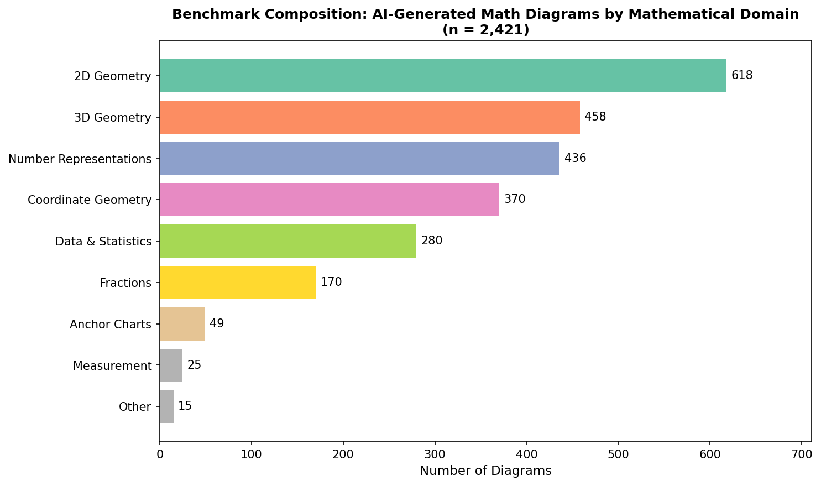

Sampling Strategy
We will draw a stratified proportional random sample of 1,000 diagrams from the full dataset. This approach maintains the natural distribution of mathematical domains. For example, 2D Geometry (25.5% of population) will contribute approximately 255 diagrams to our sample, while smaller categories like Measurement will contribute proportionally fewer.

Human Annotation Approach
Two expert annotators will rate each sampled diagram on 5 binary dimensions derived from Mayer's Cognitive Theory of Multimedia Learning (CTML):
Dimension | Yes/No Question
Coherence | Does the diagram contain only relevant visual elements (no extraneous decoration)?
Signaling | Does the diagram use visual cues (arrows, highlights, labels) to guide attention?
Spatial Contiguity | Are related elements (labels, values) placed close to what they describe?
Segmenting | Is complex information broken into digestible chunks?
Appropriate Labeling | Are essential elements labeled without over-labeling or under-labeling?
We will first annotate a small test set (~50-100 diagrams) with all annotators to establish inter-rater reliability (IRR). Once acceptable agreement is achieved, each annotator will independently code 500 diagrams across the 5 binary dimensions.

VLM Benchmarking
We will test four state-of-the-art vision-language models: Claude Sonnet 4.6, GPT-5.2, and Gemini 3.0 Pro. Additionally, we will include one open-source VLM at lower computational cost to investigate whether smaller models can match the pedagogical assessment performance of larger models.
For each diagram and dimension, we will prompt the VLM with the binary question (e.g., "Does this diagram contain only relevant visual elements with no extraneous decoration? Answer YES or NO.") and also include relevant nuances and guidelines which the authors document through during the human-judgement IRR phase to ensure a fair comparison.

Statistical Analysis
Our primary measure of VLM-human agreement is Cohen's kappa (κ), which quantifies agreement beyond chance. We will compute kappa for each VLM-dimension combination, enabling us to answer:
1. Overall: Which VLMs show highest agreement with human experts?
2. By dimension: Which pedagogical dimensions are easiest/hardest for VLMs to assess?
3. By domain: Do certain mathematical diagram types pose greater assessment challenges?
Kappa values will be interpreted using standard thresholds: <0.20 (poor), 0.21-0.40 (fair), 0.41-0.60 (moderate), 0.61-0.80 (substantial), >0.80 (near-perfect agreement).

Expected Outcomes
We anticipate that VLMs will show variable performance across pedagogical dimensions. Surface-level features (Coherence, Signaling) may yield higher agreement than dimensions requiring deeper pedagogical judgment (Segmenting, Appropriate Labeling). Similarly, simpler diagram types (e.g., number lines) may be easier to assess than complex ones (e.g., 3D shape nets).
The resulting benchmark and findings will have implications for automated quality assurance in educational diagram generation, identifying where human oversight remains essential versus where LLM-as-a-Judge could be reliable.

References
Cohen, J. (1960). A coefficient of agreement for nominal scales. Educational and Psychological Measurement, 20(1), 37–46.
Lu, P., Bansal, H., Xia, T., Liu, J., Li, C., Hajishirzi, H., Cheng, H., Chang, K.-W., Galley, M., & Gao, J. (2023). MathVista: Evaluating mathematical reasoning of foundation models in visual contexts. arXiv preprint arXiv:2310.02255.
Mayer, R. E. (2001). Multimedia Learning. Cambridge University Press.
Mayer, R. E., & Fiorella, L. (2014). Principles for reducing extraneous processing in multimedia learning: Coherence, signaling, redundancy, spatial contiguity, and temporal contiguity principles. In R. E. Mayer (Ed.), The Cambridge Handbook of Multimedia Learning (2nd ed., pp. 279–315). Cambridge University Press.
Zhang, R., Jiang, D., Zhang, Y., Lin, H., Guo, Z., Qiu, P., Zhou, A., Lu, P., Chang, K.-W., Gao, P., & Li, H. (2024). MathVerse: Does your multi-modal LLM truly see the diagrams in visual math problems? In Proceedings of ECCV 2024. arXiv preprint arXiv:2403.14624.
Zheng, L., Chiang, W.-L., Sheng, Y., Angelopoulos, A. N., Li, L., Yu, D., Zhang, J., Gonzalez, J. E., & Stoica, I. (2023). Judging LLM-as-a-judge with MT-Bench and Chatbot Arena. In Advances in Neural Information Processing Systems 36 (NeurIPS 2023). arXiv preprint arXiv:2306.05685.

